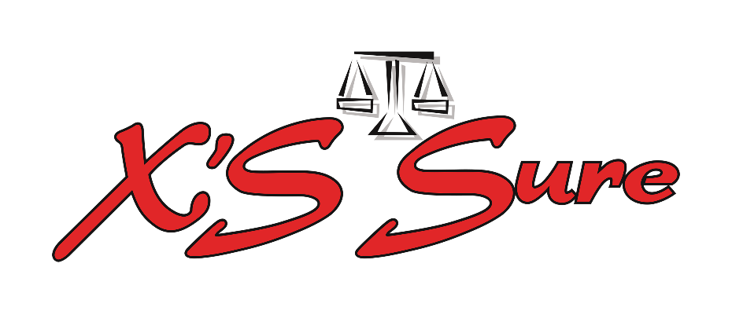

ScratchSure

Please complete the below information to assist us in handling your claim as quickly as possible. **All fields** need to be completed to pay your claim**.**

|  |
| --- |
| Personal Details |

|  |  |  |
| --- | --- | --- |
| Name | Surname | ID / Company reg nr |
| Policy nr | Tel nr | Cell nr |
| Address |  |  |
| Postal Code |  | Email |

|  |
| --- |
| Claim Details |

|  |  |
| --- | --- |
| Vehicle Registration number |  |
| Vehicle make and model |  |
| Date of loss |  |
| Full description of the damage |  |
| Location / area where the incident occurred |  |
| On what part of the vehicle is the damage |  |

|  |
| --- |
| Feedback |

|  |  |  |
| --- | --- | --- |
| Were you happy with the way that the product was initially marketed to you by your broker? | Yes | No |
| Are you happy with the way that your claim is dealt with? | Yes | No |
| Are you happy with the outcome of the claim? | Yes | No |

Client Signature X’S Sure Date

|  |
| --- |
| Claims |

In the case of an event that may result in a claim, the Insured must notify the Insurer thereof within 31 days, as well as provide details of any other policy that covers the same event and supply the Insurer with full details in writing, together with full details of the relevant underlying insurance company insuring the Insured's vehicle(s) at the time. The Insurer can repudiate claims not reported within the 31 days notification period.

Any event where theft or any other criminal act or loss is involved must be reported

to the police immediately.

All claims must be reported to the X’S Sure call center on **08600 181 40** **before** any replacement of damaged tyre/s may be done. No claim/s will be paid if the client replaces tyre/s without authorisation from X’S Sure.

Claims can be sent to : Ansofie@xssure.co.za

**The Insurer's rights after an occurrence that may lead to a claim:**

* In the event of a claim, the Insurer reserves the rights to contact the underlying insurance company to confirm the amounts deducted and to check that all documentation is complete.
* In the event of a dispute or misrepresentation, the underlying insurance company's decision will be final.
* Upon indemnification of the Insured, the Insurer expects the Insured to assist them in every way possible to exercise their right of recourse.

**X’S Sure VAT No 4140228265**

**Guardrisk VAT No 4250138072**

**Guardrisk receives a 20% Binder fee**

